CS 340 Project Two README
Grazioso Salvare Rescue Dashboard
Ashlynn Borro
Project Overview
For this project, I created an interactive dashboard for Grazioso Salvare to help identify dogs that may be suitable for search-and-rescue training. The dashboard uses animal shelter records from the Austin Animal Center and allows users to narrow down the results based on specific rescue requirements.
The main purpose of the dashboard is to make the information easier to search and understand. Instead of going through hundreds of animal records individually, users can select a rescue category and see which dogs meet the requirements. The dashboard also includes a data table, a pie chart showing the most common breeds, and a map that displays the location of a selected animal.
I reused the CRUD Python module I developed earlier in the course to connect the dashboard to MongoDB. This helped me better understand how the database and dashboard work together.

Dashboard Functionality
The dashboard includes several features that work together to help users review and compare animal records.
Interactive Data Table
The data table displays records retrieved from MongoDB, including information such as animal type, breed, sex, age, name, and location. Users can view animal records based on the selected rescue filter and select individual animals to see additional information on the geolocation map.
When an animal is selected, the geolocation map updates to show the location associated with that record. This makes it easier to review the animal's information without having to search for it separately.
Rescue Filters
I created three rescue filters along with a Reset option. Each filter uses a MongoDB query to find dogs that meet the breed, sex, and age requirements provided for that category.
- Water Rescue: This filter looks for Labrador Retriever Mix, Chesapeake Bay Retriever, and Newfoundland dogs. The requirements include intact females between 26 and 156 weeks old.
- Mountain or Wilderness Rescue: This filter looks for German Shepherd, Alaskan Malamute, Old English Sheepdog, Siberian Husky, and Rottweiler dogs. The requirements include intact males between 26 and 156 weeks old.
- Disaster or Individual Tracking: This filter looks for Doberman Pinscher, German Shepherd, Golden Retriever, Bloodhound, and Rottweiler dogs. The requirements include intact males between 20 and 300 weeks old.
- Reset: This option removes the rescue filters and returns the dashboard to the original dataset.
When a filter is selected, the data table updates to show the matching records. The pie chart also changes based on the information being displayed.
Breed Distribution Chart
I used Plotly Express to create a pie chart showing the top 10 breeds in the displayed records. The chart changes depending on which rescue filter is selected.
This gives users a quick way to see which breeds are represented in each category without having to look through the entire table.
Geolocation Map
The geolocation map was created using Dash Leaflet. When a user selects an animal from the data table, the map displays a marker at the coordinates associated with that record.
Hovering over the marker displays the animal's breed, and clicking it opens a popup showing the animal's name. I also added checks for missing or invalid coordinates and row selections so the map can handle incomplete information without causing unnecessary errors.
Dashboard Identification
I included the Grazioso Salvare logo, dashboard title, and my name at the top of the application. This helps identify the dashboard and gives it a more complete appearance.
Tools and Technologies Used
I used several tools throughout this project, with each one serving a different purpose.

MongoDB
MongoDB was used to store and retrieve the Austin Animal Center records. I used MongoDB because it works well with document-based information and allows records to be filtered using specific queries.
For this project, MongoDB served as the model in the model-view-controller (MVC) design because it stores the data that the dashboard uses.
Python and PyMongo
Python was the main programming language used to build the dashboard. I reused my AnimalShelter CRUD module from an earlier assignment to connect to MongoDB and retrieve the animal records.
PyMongo allows Python to communicate with MongoDB. Using a separate CRUD module made it easier for me to keep the database connection code organized instead of putting everything directly into the dashboard.
Dash and JupyterDash
I used Dash to build the dashboard layout and interactive features, including the data table, rescue filters, pie chart, and map.
Dash uses callbacks to respond when users interact with the application. For example, selecting a rescue category triggers a callback that retrieves the matching records and updates the table. Other callbacks update the chart and map.
In the MVC design, Dash provides the view through the dashboard layout and the controller through its callbacks. The view displays the information, while the controller handles user selections and updates what appears on the dashboard.
JupyterDash allowed me to run the application through Jupyter Notebook.
Pandas
Pandas was used to convert the MongoDB records into a DataFrame. This made it easier to organize the information before displaying it in the table and chart.
Plotly Express
I used Plotly Express to create the breed distribution pie chart. It works with Dash and allows the chart to update when the displayed data changes.
Dash Leaflet
Dash Leaflet was used to create the interactive map. It allowed me to display animal locations using latitude and longitude values and include additional information through a tooltip and popup.
Codio and Jupyter Notebook
I used Codio and Jupyter Notebook to develop and test the project. These tools allowed me to work with my Python files, connect to MongoDB, run the application, and view the dashboard in a browser.
Steps Taken to Complete the Project
I started by connecting my existing CRUD Python module to MongoDB. Once the connection was working, I used Pandas to convert the retrieved animal records into a DataFrame. I also removed the MongoDB _id field from the displayed records because it was not needed in the dashboard.
Next, I created the dashboard layout using Dash. I added the Grazioso Salvare logo, title, my name, rescue filters, and interactive data table.
After setting up the layout, I created MongoDB queries for the three rescue categories. Each query uses the required breed, sex, and age range to retrieve matching dogs. I connected these queries to the filter controls using a Dash callback.
Once the filters were working, I added the pie chart using Plotly Express. I created another callback so the chart would update based on the records displayed in the table.
The next part was creating the geolocation map using Dash Leaflet. I connected the map to the data table so that selecting an animal would update the marker to its recorded location.
I also added checks for missing coordinates and invalid selections to help prevent errors. After completing the main features, I tested each rescue filter, the Reset option, the pie chart, and the map to make sure they were responding correctly.
Challenges and How I Resolved Them
One of the first issues I ran into was connecting the dashboard to MongoDB. When I tried running the notebook, I received an authentication error because the password in my connection settings did not match my MongoDB account. After correcting the password, I was able to retrieve the animal records.
Another issue involved the data table's column-highlighting callback. I received a NoneType error because the callback was trying to process selected columns when nothing had been selected. I fixed this by adding a condition that returns an empty list when there is no selection.
The geolocation map was probably the part I had the most trouble with. At first, the data table and pie chart were displaying correctly, but the map was not appearing at all. I went back through the layout and adjusted the map container's width and minimum height. After making those changes, the map finally displayed.
Once the map was visible, I noticed that selecting an animal did not update the marker the way I expected. I added single-row selection to the data table, which allowed users to select an animal using the radio button beside its record. After that, the marker updated when I selected a different animal.
I also made changes to the map callback to handle missing coordinates, invalid coordinate values, and selections that were outside the available records. This was important because I wanted the dashboard to handle unexpected information without producing another error.
Fixing these problems helped me better understand how one part of the dashboard can affect another. It also reminded me how important it is to test each feature individually instead of assuming everything works just because the dashboard loads.
Instructions for Reproducing the Project
The following steps explain how someone could set up and run the dashboard using the required files and software.
- Prepare the environment. Open a Python environment that supports Jupyter Notebook and has access to MongoDB.
- Install the required libraries. Make sure the environment includes PyMongo, Pandas, Dash, JupyterDash, Plotly, and Dash Leaflet.
- Prepare MongoDB. Confirm that the MongoDB server is running and that the Austin Animal Center dataset has been imported. The database needs to contain the fields used by the dashboard, including animal type, breed, sex, age, name, and location coordinates.
- Configure the database connection. Make sure the MongoDB account has permission to read the animal records. Update the connection settings using valid credentials. Passwords should not be included in shared documentation or screenshots.
- Organize the project files. Place CRUD_Python_Module.py, ProjectTwoDashboard.ipynb, and Grazioso Salvare Logo.png in the same working directory.
- Open the notebook. Open ProjectTwoDashboard.ipynb in Jupyter Notebook through Codio or another compatible environment.
- Verify the connection. Make sure the notebook imports the AnimalShelter class from the CRUD module and that the MongoDB connection is configured correctly.
- Run the notebook. Run the cells in order or select the option to restart the kernel and run all cells.
- Open the dashboard. Use the application link provided by the environment. In Codio, the dashboard runs through the proxy for port 8050.
- Test the rescue filters. Select Water Rescue, Mountain or Wilderness Rescue, and Disaster or Individual Tracking. Check that the data table and pie chart update for each selection.
- Test the map. Select an animal using the radio button beside its row. The map should update to show its location, and clicking the marker should display the animal's name.
- Test Reset. Select Reset to return the dashboard to the original dataset.
The dashboard requires access to a MongoDB database with the same structure and field names used during development. If the database or environment is different, some connection settings or queries may need to be adjusted.

Dashboard Testing and Screenshots
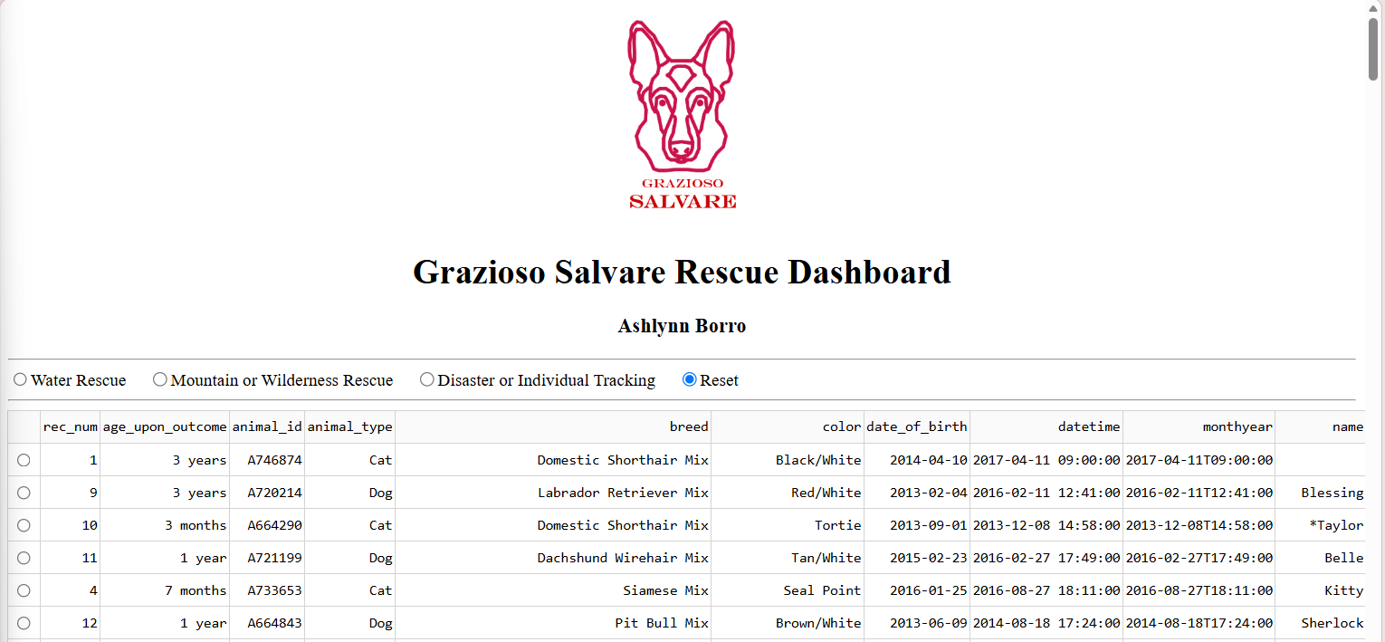
Figure 1. Dashboard Logo, Title, and Unique Identifier

This screenshot shows the Grazioso Salvare logo, dashboard title, and my name displayed at the top of the application. I included these elements to meet the project requirements and make the dashboard easy to identify. The logo represents the organization, while the title explains the purpose of the dashboard. I also added my name as a unique identifier to distinguish my project from the original starter code.

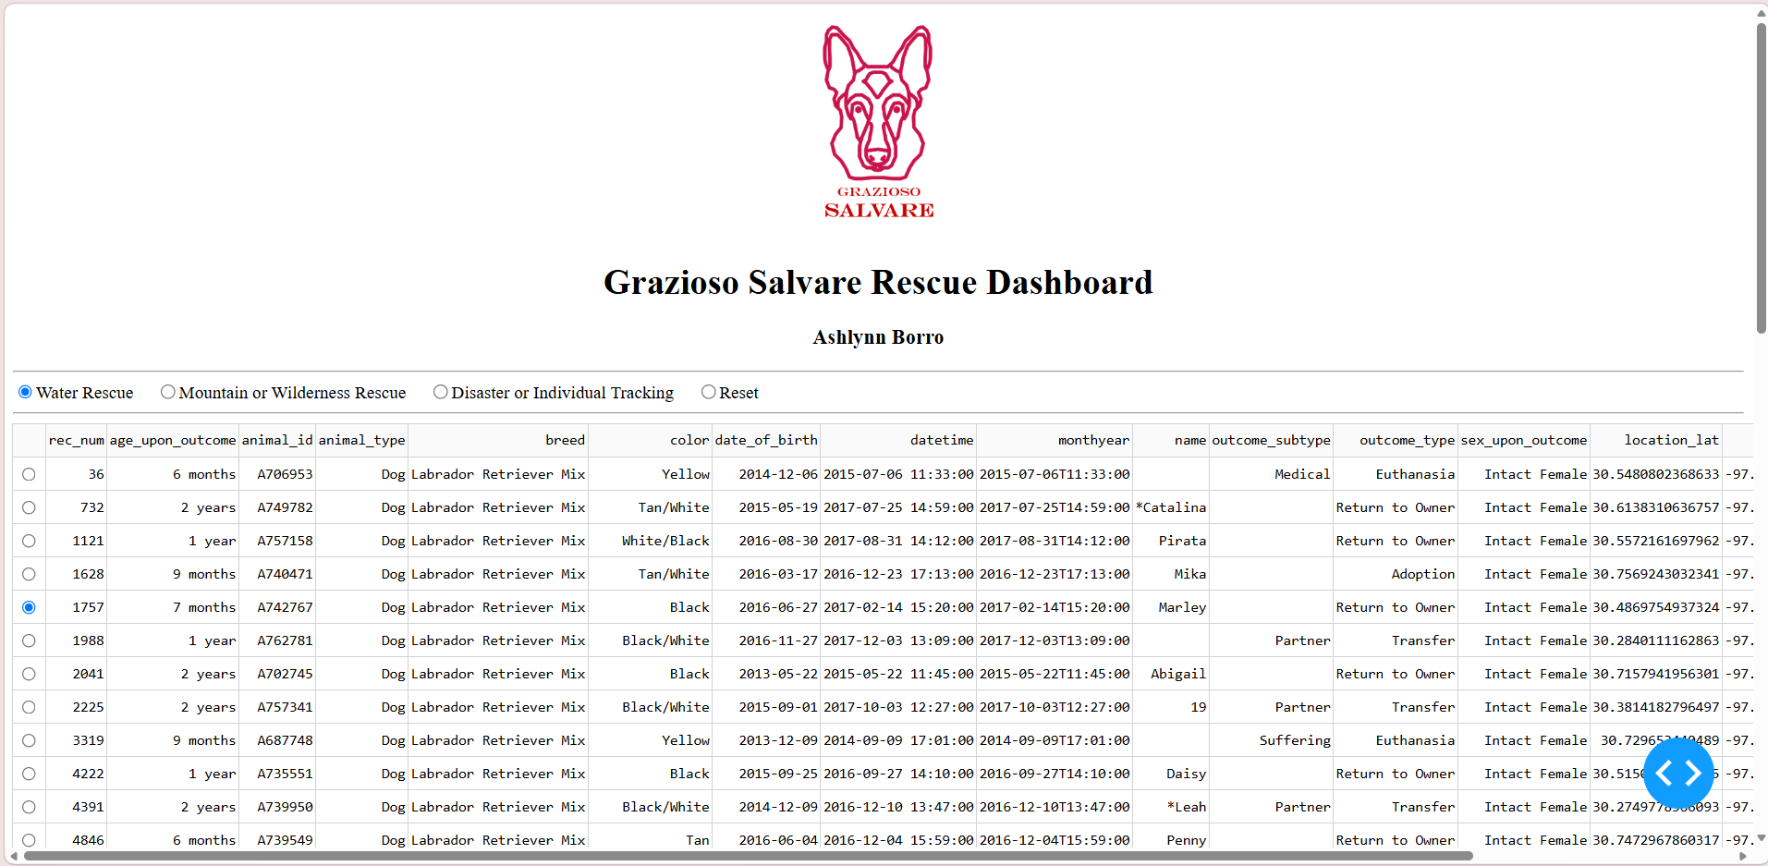
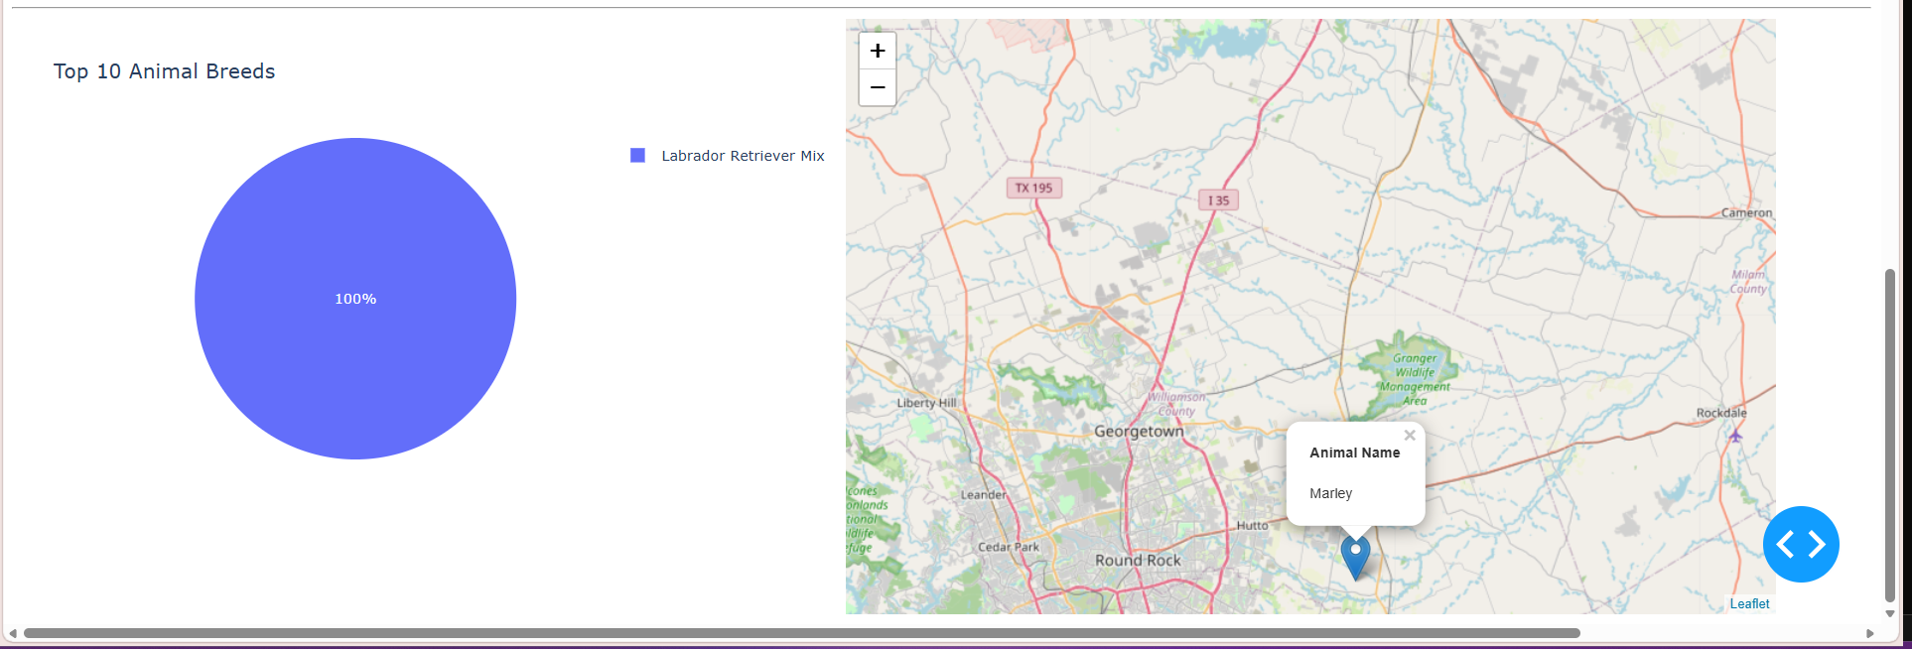
Figure 2. Water Rescue Filter

This screenshot shows the Water Rescue filter selected. The data table displays the matching records, while the pie chart shows the breeds represented in the results. The map also displays the location and identifying information for the selected animal.

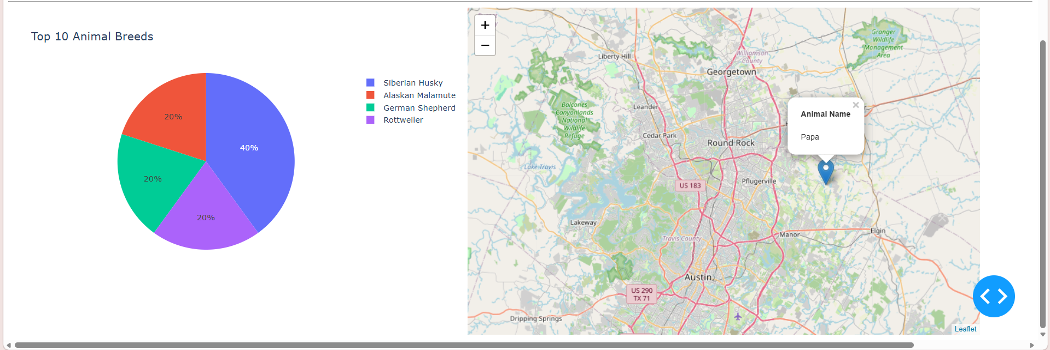
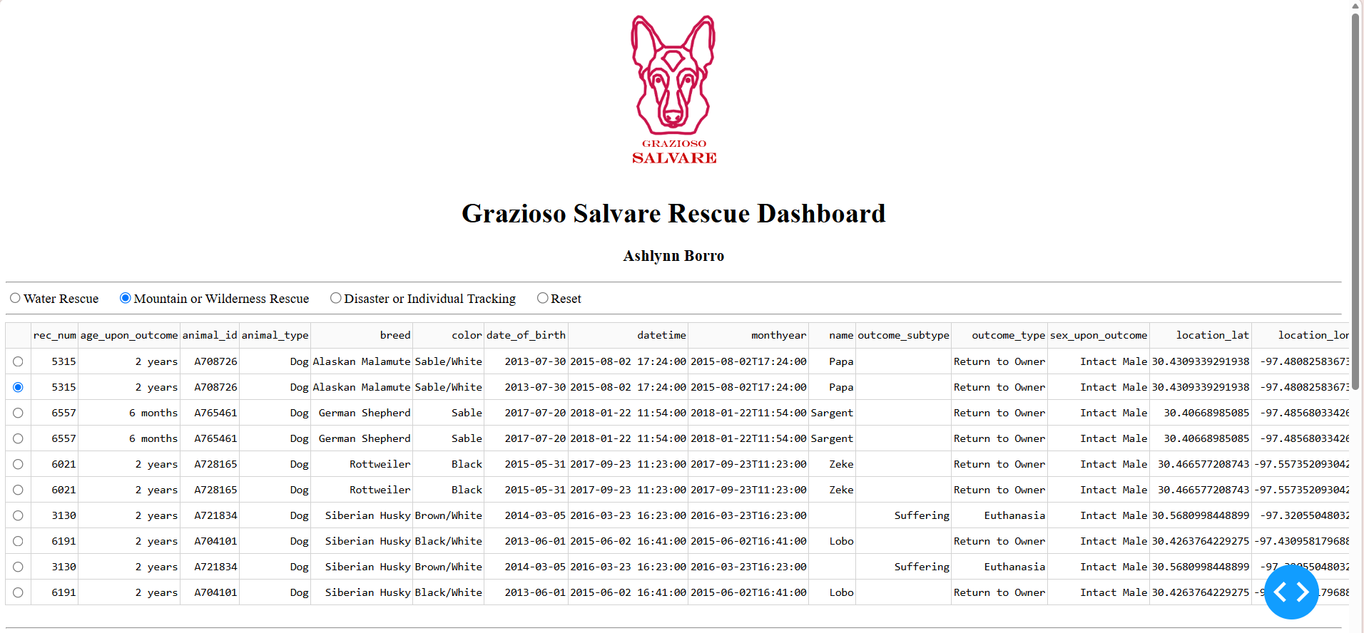
Figure 3. Mountain or Wilderness Rescue Filter

This screenshot shows the Mountain or Wilderness Rescue filter. The table and pie chart update based on the selected category, and the map displays the selected animal's location.

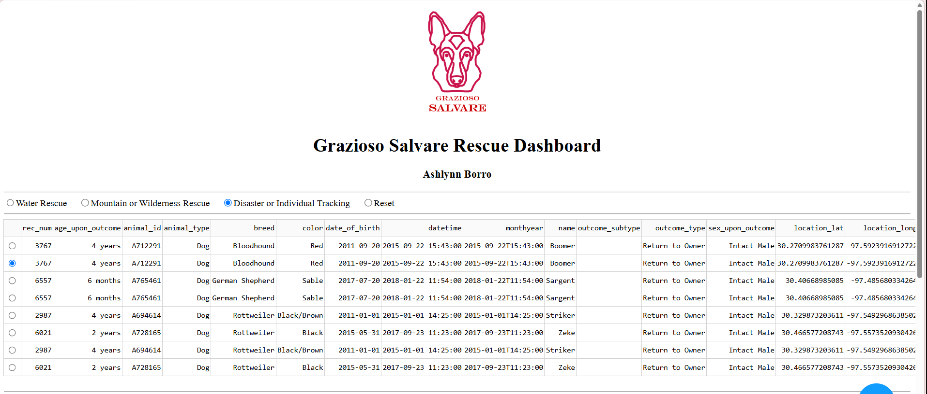
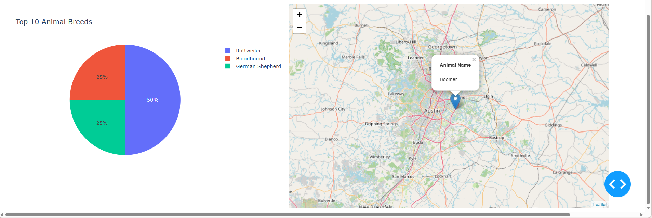
Figure 4. Disaster or Individual Tracking Filter

This screenshot demonstrates the Disaster or Individual Tracking filter. The data table displays matching records, and the pie chart changes to reflect the breed distribution for that category.

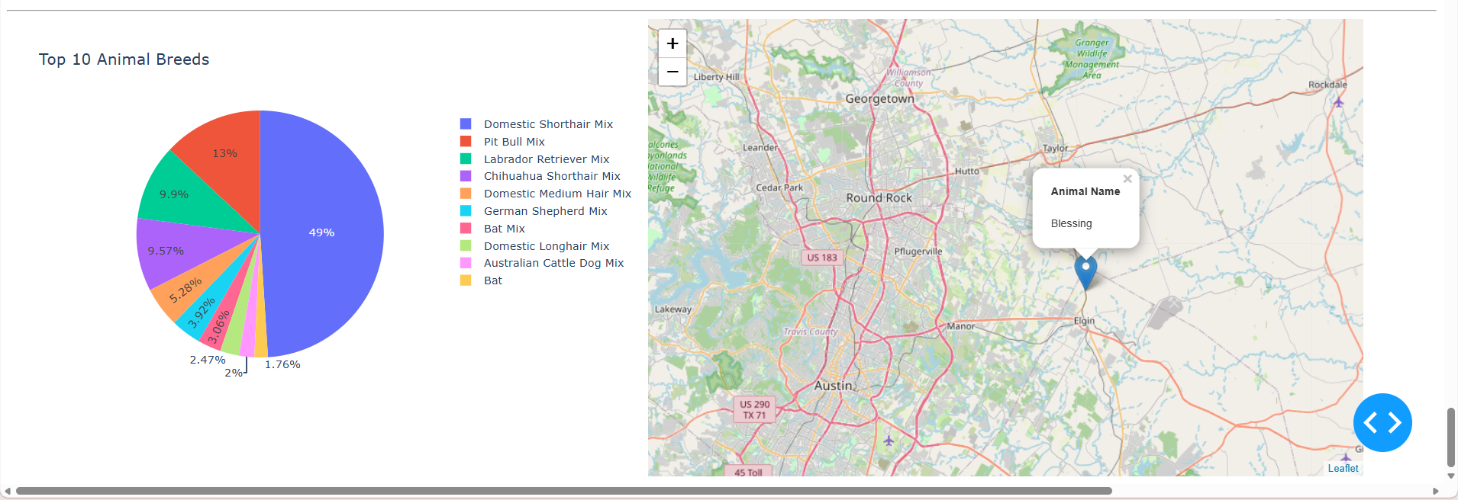
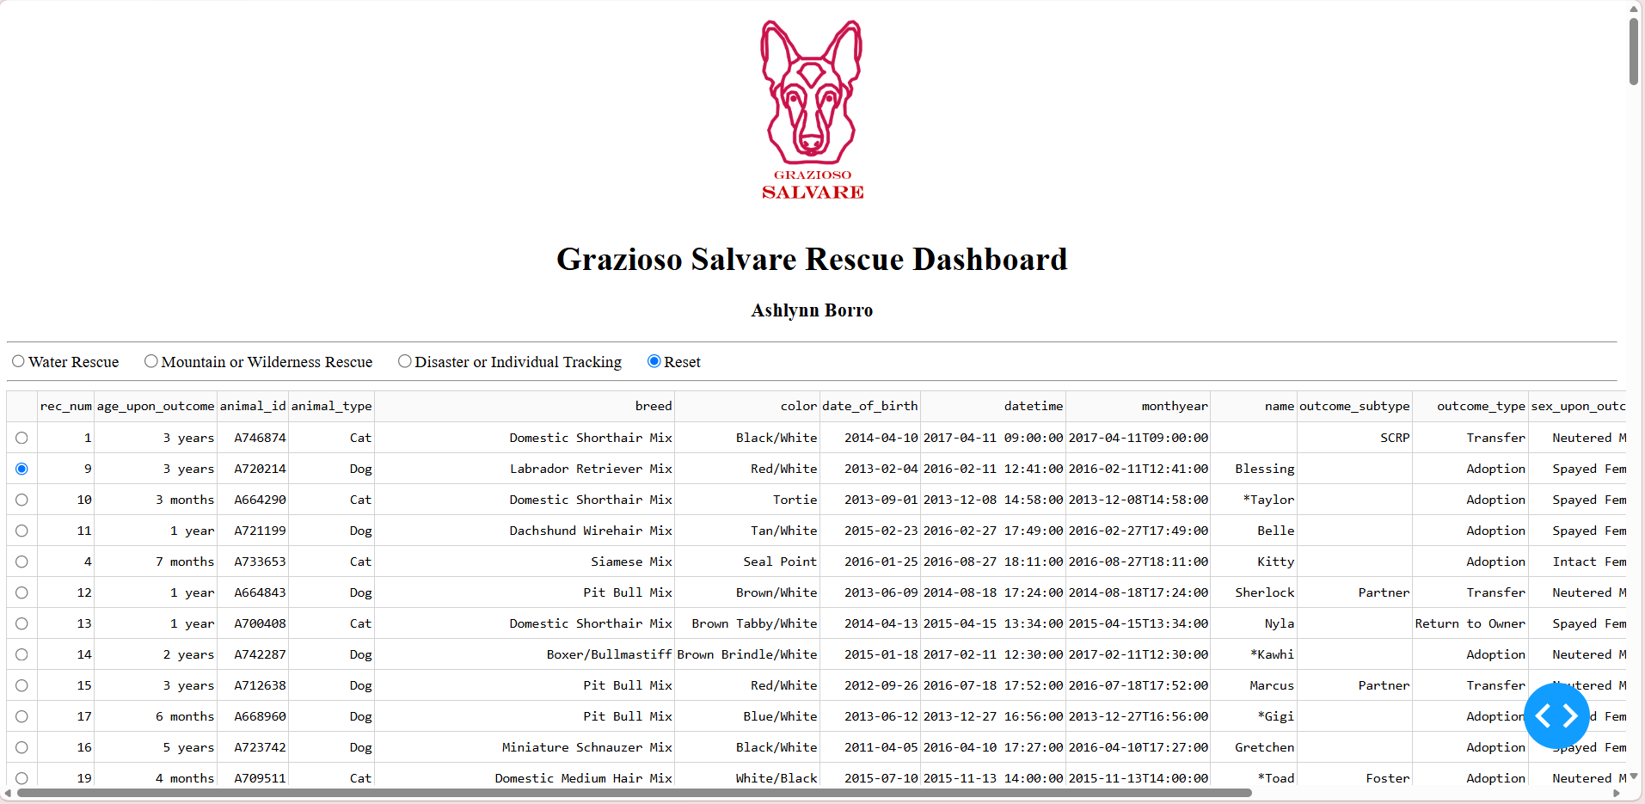
Figure 5. Reset Filter

This screenshot shows the Reset option returning the dashboard to the unfiltered animal records. The pie chart also updates to display the breed distribution from the original dataset.

Resources and Software References
MongoDB. (n.d.). MongoDB documentation. https://www.mongodb.com/docs/
MongoDB. (n.d.). PyMongo documentation. https://pymongo.readthedocs.io/
Plotly. (n.d.). Dash documentation. https://dash.plotly.com/
Plotly. (n.d.). Plotly Python documentation. https://plotly.com/python/
Dash Leaflet. (n.d.). Dash Leaflet. https://www.dash-leaflet.com/
Conclusion
This project gave me the opportunity to apply what I learned throughout CS-340 by connecting MongoDB to a Python application and building an interactive dashboard around the animal shelter records.
The most challenging part was getting all the different components to work together, especially the callbacks and geolocation map. However, working through those issues helped me better understand how the database, application logic, and dashboard interact.
Overall, the completed dashboard allows users to filter animal records by rescue category, review the results in a data table, compare breeds using a pie chart, and view animal locations on a map. It shows how a database and an interactive application can work together to make a large amount of information easier to access and understand.

